**Siddaganga Institute of Technology, Tumakuru**

(An Autonomous Institution affiliated to Visvesvaraya Technological University, Belagavi, Approved by

AICTE, New Delhi, Accredited by NAAC and ISO 9001:2015 certified)

**A Report on Open Ended Problem titled**

# **“**OBSTACLE AVOIDING BOT USING ARDUINO**”**

submitted

*in the partial fulfillment of the requirements for IV semester*

*Bachelor of Engineering*

In

*Computer Science and Engineering*

by

**OJAS SANGRA 1SI20CS069**

**PARAS KATAL 1SI20CS072**

**TANMAI TICKOO 1SI20CS118**



**Department of Computer Science & Engineering**

(Program Accredited by NBA)

**Siddaganga Institute of Technology**

B.H Road, Tumakuru-572 103, Karnataka, India.

Web: [www.sit.ac.i](http://www.sit.ac.i)[n](http://www.sit.ac.in/)  2021-2022

# **Siddaganga Institute of Technology, Tumakuru**

(An Autonomous Institution affiliated to Visvesvaraya Technological University, Belagavi, Approved by AICTE, New Delhi, Accredited by NAAC and ISO 9001:2015 certified)

## Department of Computer Science and Engineering

(Program Accredited by NBA)



## CERTIFICATE

This is to certify that open ended problem titled “**OBSTACLE AVOIDING BOT USING** **AURDINO**” is a Bonafide work carried out by **PARAS (1SI20CS072), OJAS(1SI20CS069), TANMAI(1SI20CS118)** of IV semester **Bachelor of Engineering in** **Computer Science and Engineering** of the **SIDDAGANGA INSTITUTE OF TECHNOLOGY**

(An Autonomous Institution, affiliated to VTU, Belagavi, Approved by AICTE, New Delhi, Accredited by NAAC and ISO 9001:2015 certified) during the academic year 2021-2022.

**Name of the Panel Members Signature with Date**

**1. Dr K.G. Manjunath**

**TABLE OF CONTENTS:**

|  |  |  |
| --- | --- | --- |
| **Sl.No.** | **Contents** | **Page No.** |
| 1 | Introduction | 4 |
| 2 | Components Used | 5 |
| 3 | Project Overview | 7 |
| 4 | Circuit diagram | 9 |
| 5 | Implementation using code | 10 |

### CHAPTER 1

**Introduction**

An [Obstacle Avoidance Robot](https://www.pantechsolutions.net/robotics/obstacle-avoidance-robot) is an intelligent robot, which can automatically sense and overcome obstacles on its path. It contains of a Microcontroller to process the data, and [Ultrasonic sensors](https://www.pantechsolutions.net/sensors/ultrasonic-sensor) to detect the obstacles on its path. This design allows the robot to navigate in an unknown environment by avoiding collisions, which is a primary requirement for any autonomous mobile robot.

### ****Advantages of Obstacle Avoiding Robot:****

1. These Robots are easy and quick to compute.
2. These are not affected by the noise in the surrounding.
3. These can easily detect the object at a distance.
4. These can easily detect the edges and their respective orientation.

CHAPTER 2

COMPONENTS USED

* Arduino Uno
* Ultrasonic Sensor
* Motor Driver
* Geared Motors x 2
* Robot Chassis
* Power Supply
* Battery Connector
* Battery Holder

1.ARDUINO

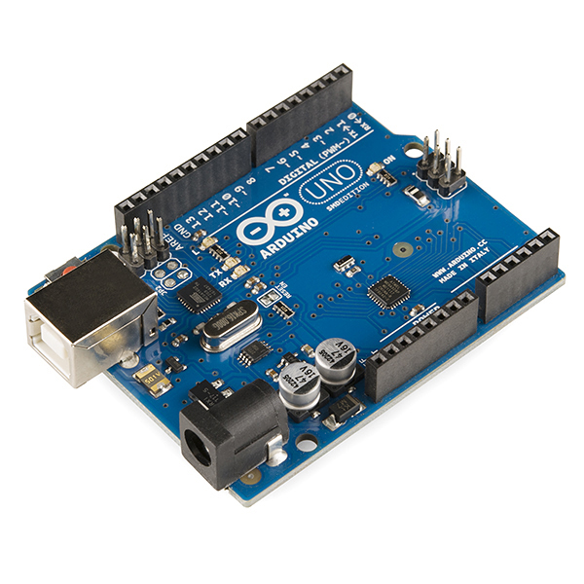

2.ULTRASONIC SENSOR:

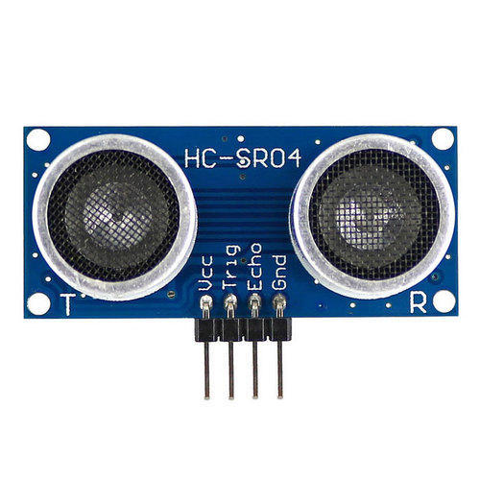

3.JUMPER WIRES:

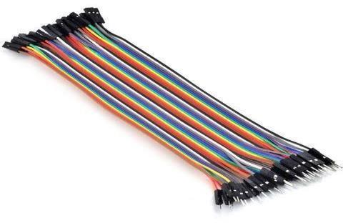

4.CONNECTOR:

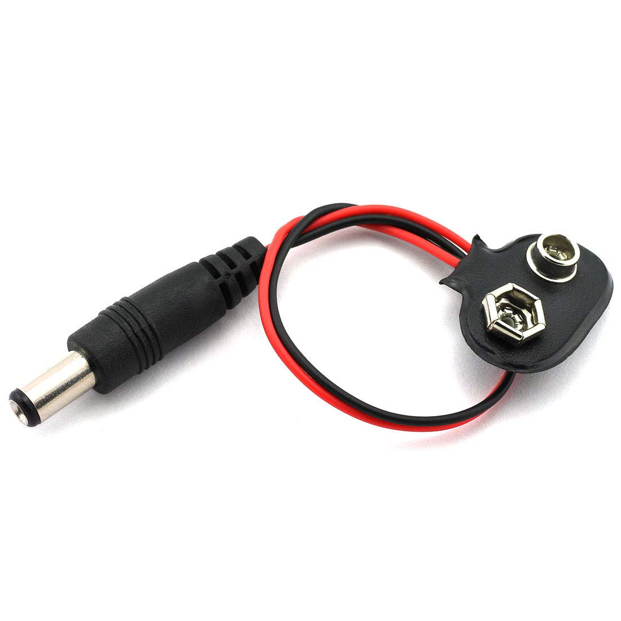

CHAPTER 3

PROJECT OVERVIEW

The basic principle behind the working of ultrasonic sensor is to note down the time taken by sensor to transmit ultrasonic beams and receiving the ultrasonic beams after hitting the surface. Then further the distance is calculated using the formula. In this project, the widely available **HC-SR04 Ultrasonic Sensor** is used.

So, the Trig pin of HC-SR04 is made high for at least 10 us. A sonic beam is transmitted with 8 pulses of 40KHz each.

[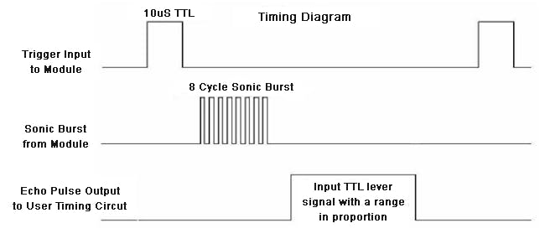](javascript:openLightBox('893d5886fc',%200);)

Fig:1.1

The signal then hits the surface and return back and captured by the receiver Echo pin of HC-SR04. The Echo pin had already made high at the time sending high.

](javascript:openLightBox('2fdd05c29b',%200);)

fig:1.2

The time taken by beam to return back is saved in variable and converted to distance using appropriate calculations like below

Distance= (Time x Speed of Sound in Air (343 m/s))/2

CHAPTER 4

CIRCUIT DIAGRAM

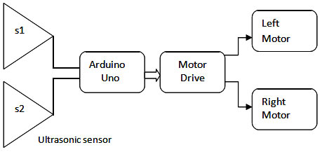

Fig:1.3

CHAPTER 5

IMPLEMENTATION USING CODE

#define en1 11

#define en2 12

int trigPin = 9; // trig pin of HC-SR04

int echoPin = 10; // Echo pin of HC-SR04

int revleft4 = 4; //REVerse motion of Left motor

int fwdleft5 = 5; //ForWarD motion of Left motor

int revright6 = 6; //REVerse motion of Right motor

int fwdright7 = 7; //ForWarD motion of Right motor

long duration, distance

void setup() {

delay(random(500,2000)); // delay for random time

Serial.begin(9600);

pinMode(revleft4, OUTPUT); // set Motor pins as output

pinMode(fwdleft5, OUTPUT);

pinMode(revright6, OUTPUT);

pinMode(fwdright7, OUTPUT);

pinMode(trigPin, OUTPUT); // set trig pin as output

pinMode(echoPin, INPUT); //set echo pin as input to capture reflected waves

}void loop() {

digitalWrite(trigPin, LOW);

delayMicroseconds(2);

digitalWrite(trigPin, HIGH); // send waves for 10 us

delayMicroseconds(10);

duration = pulseIn(echoPin, HIGH); // receive reflected waves

distance = duration / 58.2; // convert to distance

delay(10);

// If you dont get proper movements of your robot then alter the pin numbers

if (distance > 19)

{

digitalWrite(fwdright7, HIGH); // move forward

digitalWrite(revright6, LOW);

digitalWrite(fwdleft5, HIGH);

digitalWrite(revleft4, LOW);

}

if (distance < 18)

{

digitalWrite(fwdright7, LOW); //Stop

digitalWrite(revright6, LOW);

digitalWrite(fwdleft5, LOW);

digitalWrite(revleft4, LOW);

delay(500);

digitalWrite(fwdright7, LOW); //movebackword

digitalWrite(revright6, HIGH);

digitalWrite(fwdleft5, LOW);

digitalWrite(revleft4, HIGH);

delay(500);

digitalWrite(fwdright7, LOW); //Stop

digitalWrite(revright6, LOW);

digitalWrite(fwdleft5, LOW);

digitalWrite(revleft4, LOW);

delay(100);

digitalWrite(fwdright7, HIGH);

digitalWrite(revright6, LOW);

digitalWrite(revleft4, LOW);

digitalWrite(fwdleft5, LOW);

delay(500);

}

}

REFERENCES:

1. <https://mysparklebox.com/blog/obstacle-avoiding-robot/>
2. <https://create.arduino.cc/projecthub/Alfa0420/obstacle-avoiding-robot-using-arduino-and-ultrasonic-sensor-c179bb>
3. <https://globaljournals.org/GJRE_Volume17/2-Obstacle-Avoiding-Robot.pdf>
4. <https://www.researchgate.net/publication/329042229_Design_of_an_Obstacle-avoiding_Robot_Car_Based_on_Arduino_Microcontroller>